Live Connect, CloudActiv8 Remote Control, Quick View, User Portal

**Quick Start Guide**

**Copyright Agreement**

The purchase and use of all Software and Services is subject to the Agreement as defined in CloudActiv8’s “Click-Accept” EULA as updated from time to time by CloudActiv8 at http:/[/www.CloudActiv8.com](http://www.kaseya.com/jp/legal.aspx)/legal.aspx. If Customer does not agree with the Agreement, please do not install, use or purchase any Software and Services from CloudActiv8 as continued use of the Software or Services indicates Customer’s acceptance of the Agreement.”

Contents

CloudActiv8 Remote Control 4

Recording KRC Sessions 7

Live Connect 7

Manage Servers 12

Live Connect on Demand 13

Custom Extensions 15

Live Connect to SSH Assets 16

Live Connect Mobile 17

Live Connect PowerShell 19

Live Connect File and Folder Transfers 20

CloudActiv8 User Portal 21

Live Connect (Classic) 21

Setting User Role Access Rights for Live Connect (Classic) 26

Customize: Live Connect (Classic) 27

Customized New Ticket Link in Live Connect (Classic) 28

Quick View (Classic) 28

Portal Access (Classic) 29

Setting Machine Role Access Rights for Portal Access (Classic) 29

Accessing Portal Access (Classic) Remotely 31

Enabling Ticketing for Portal Access (Classic) Users on Unsupported Browsers 32

**Quick View**

Hovering the cursor over a check-in icon displays an agent **Quick View** window immediately. You can use **Quick View** to:

* View agent properties
* Start a shared or private **CloudActiv8 Remote Control** session
* Launch an agent procedure
* Launch **Live Connect**

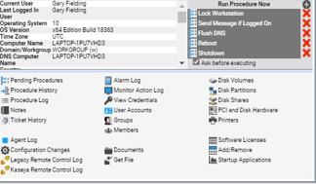

# CloudActiv8 Remote Control

**CloudActiv8 Remote Control** is the primary remote-control capability used throughout **Virtual System Administrator™**. **CloudActiv8 Remote Control** connects in seconds to remote machines that already have **CloudActiv8 Remote Control** installed. **CloudActiv8 Remote Control** maintains a reliable, secure and encrypted connection.

#### Starting CloudActiv8 Remote Control

Click any agent icon  that supports **CloudActiv8 Remote Control** to automatically start or re-start it. You can also hover over the agent icon to display **Quick View** *.* Click the **Remote Control** button to launch **CloudActiv8 Remote Control**. You can also click the **Live Connect** button in **Quick View**.

#### Types of Sessions

* **Terminal Server Sessions** - You can remote into a Terminal Server, then select a user session to shadow. Shadow means the administrator shares the console session with the end user and can provide assistance to the user. The Terminal Services role must be enabled on supported Windows servers to use this feature and the group policy to shadow enabled.
* **Private Remote-Control Sessions** - You can also use the **Private Remote Control** button in the **Quick View** *(page i)* window to launch a private session. Private sessions enable administrators to connect to a machine, logon and remote control the machine without accessing the console. An end user working on the same machine at the same time cannot see the administrator's private session. Private sessions also allow you to connect to headless environments where no display drivers are installed.

**Features**

* Supports remote control with or without a machine user being logged in.
* Connects to the console session by default. If a user is logged on, the administrator shares the console session with the user.
* Allows the administrator to select any additional *monitors* that may be running on the remote system. Support viewing multiple monitors using different resolutions.
* Support for HiDPI Windows endpoints.
* Multiple view sessions can connect to the same agent machine, viewing the same monitor or different monitors, so long as the endpoint supports multiple concurrent connections.
* Copies and pastes (CTRL+C and CTRL+V) *plain text* between local and remote systems. Both systems share the same clipboard.
* Connects when a Windows machine is booted into *Safe Mode with Network*.
* CloudActiv8 Remote Control sessions can be recorded. See **Recording KRC Sessions**.

#### Keyboard Mappings, Keyboard Toggle and Keyboard Shortcuts

By default CloudActiv8 Remote Control acts as if you are sitting in front of the machine you are controlling. So if you are controlling a French machine, for example, your keyboard will act like a French keyboard. This is fine if you have a French keyboard, but if you have a US English keyboard some of the characters will be on different keys or might not exist. VNC has the same issue.

The following methods can be used to work with remote keyboards.

* For Windows to Windows CloudActiv8 Remote Control sessions you can toggle between the keyboard layout used by your remote machine and the keyboard layout used by your local machine.
* CloudActiv8 Remote Control supports the use of numerous native **Windows and Apple shortcut keys**on the remote machine. Keyboard shortcuts send fixed characters to the remote machine, even if it uses a different language keyboard.
* Use the on-screen keyboard on the remote machine.
* Administrators can temporarily change the keyboard layout on the remote machine to map to their local keyboard.

#### Logging

* CloudActiv8 Remote Control events are logged in the **Remote-Control** log on the Agent > Agent Logs page. Log entries include the start time, end time, remote host ended the session, admin ended the session, session was ended unexpectedly, length of session, session admin name, name of the remote machine.
* You can set the number of days to maintain both the **CloudActiv8 Remote-Control Log** and the **Legacy Remote Control Log** on the Agent > Log History page. An additional checkbox specifies whether to archive these logs.

#### Reporting

* A built-in **CloudActiv8 Remote-Control Log** report part can be used to create **Info Center** reports and report templates.
* A built-in **Remote-Control Log** report template incorporates this report part.

#### User Interface

The basic layout of the **CloudActiv8 Remote-Control** user interface includes the following:

* The machine name displays at the top of the remote-control session window.
* A narrow menu bar displays at the top.
* A session latency indicator shows the latency in milliseconds between the administrator’s local machine and the remote machine.
* When connecting to Windows machines only, a ‘Send CTRL+ALT+DEL’ option displays in the menu bar for remote logins.
* When multiple monitors are available on the remote machine, a drop-down list of monitors displays and can be selected to display a specific monitor.
* Closing the window disconnects the session.

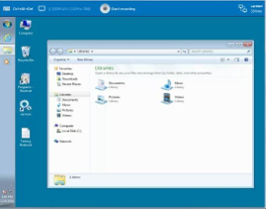

#### Installing and Updating CloudActiv8 Remote Control

**CloudActiv8 Remote Control** is installed as a viewer/server pair of applications: the viewer on the administrator's local machine and the server on the remote agent machine. The **CloudActiv8 Remote Control** server is installed as a component of the agent when a new agent is installed, or when the agent is updated using Agent > Manage Agents.

If the **CloudActiv8 Remote Control** application is not already installed on your local administrator machine, when you start your first session a dialog prompts you to download and install it. If already installed and a CloudActiv8 patch release has made a later version available, a dialog prompts you to download and install the updated version.

# Recording KRC Sessions

CloudActiv8 Remote Control sessions can be recorded. Recordings can be set by policy using the Remote Control > User Role Policy and Machine Policy pages.

1. Start a KRC session from **Live Connect**.
2. Click the new **Recording...** button in the control bar to start the recording. The recording ends when the KRC session ends.
3. View the KRC recorded sessions on the Agent > Agents > Screen Recordings page.
4. Click any of the listed *.webm video recording files to download it.
5. Run the *.webm file using any CloudActiv8 supported browser.

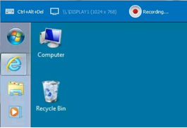

# Live Connect

The **Live Connect** app is a single-machine user interface that runs natively on your local machine, independent of the browser you are using to log into the CloudActiv8. The **Live Connect** app is designed using a Material Design look and feel.

* The first page you see is the **Asset Summary** page.
* Multiple icons along the left provide access to other menus or pages.
* You can click the add tab icon to work with multiple menu options for the same machine at the same time.
* Most data lists throughout **Live Connect** can be filtered and sorted.
* **Live Connect** sessions continue without user interruption, even if the CloudActiv8 user logs out of the CloudActiv8 or the CloudActiv8 session times out.
* Enhanced Live Connect features do not display until agents are updated.

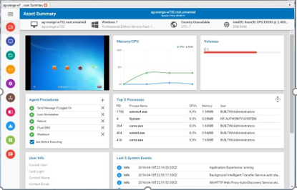

##### Launching Live Connect

* If you hover the cursor momentarily over the agent icon, the Quick View window displays. You can use Quick View to launch **Live Connect**.
* Ctrl+clicking the agent icon launches **Live Connect** immediately.
* The first time you launch **Live Connect**, you are prompted to download and install the **Live Connect** app on your local computer.
* You can also launch **Live Connect** independently of the CloudActiv8 using:
  + The **Agent/Asset Browser**
  + **Live Connect Mobile**
  + A **Custom URL Scheme**

**Menus and Options**

* Asset > **Asset Summary** - Serves as the landing page. Provides basic information about the managed machine.
  + **Machine Info** - Lists basic information about the managed machine.
  + **Thumbnail View** - The desktop of the currently logged on user displays in a thumbnail view, if a user is logged onto the machine.
  + **Memory/CPU/Volume** - Shows CPU %, memory % and disk space volume for the managed machine.

###### Agent Procedures

* + **Top 5 Processes**
  + **Agent Procedures**
  + **Top 5 Processes**
  + **User Info**
  + **Last 5 System Events**
  + **Network Info**
  + **Asset Info**
* Asset > **Asset Info**

###### Computer Information

* + **Disk Volumes**
  + **Memory Devices**
  + **Network Info**
  + **On Board Devices**
  + **PCI and Disk Hardware**
  + **Port Connectors**
  + **Printers**
  + **System Info**
  + **System Slots**
  + **Time Information**
* Asset > **Documents** - Maintains a list of documents stored on the CloudActiv8 Server associated with this machine. This same list can be maintained using the Audit > Documents page.
* Asset > **Log Viewer**

###### Agent

* + **Alarm**
  + **Monitor Action**
  + **Configuration Changes**
  + **Legacy Remote Control**
  + **CloudActiv8 Remote Control**
* Asset > **Patch Status**
* Asset > **Procedures**

###### History

* + **Logs**
  + **Pending** - You can run, schedule or delete a pending procedure. You can also select and schedule a different procedure to run.

###### Run

* Asset > **Software**

###### Add / Remove

* + **Installed Apps**
  + **Licenses**
  + **Startup**
* Asset > **Users**

###### Accounts

* + **Credentials**
  + **Groups**
  + **Members**
* Remote Control > **Shared Session** or **Private Session** - Initiates a **CloudActiv8 Remote Control**

session.

###### Keyboard

* + **Monitor selector**
  + **Latency indication**
* **Files** - Provides a file manager for the remote machine. Includes the ability to **upload and download files and folders** between the local machine and remote machines. *Item Icons*

**Drive ** This item is a drive. The icon changes based on the type of drive. A tooltip describes the type of drive.

**Folder ** This item is a folder.

**File ** This item is a file.

*List Item Options*

**Download ** Downloads the selected file. **Rename ** Renames the select file or folder. **Delete ** Deletes the selected file or folder.

**Move to ** Moves the selected file or folder to another folder.

**Make a Copy ** Copies the selected file or folder

*Header Options*

**Refresh** Refreshes the page.

**Upload ** Uploads a file.

**Create Folder ** Creates a new folder in the current folder.

**Show Transfers ** Displays file transfers. Useful if the file is particularly large.

**Filter ** Displays fields to filter the rows displayed.

###### (More Options)

**Download ** Downloads selected files and folders.

**Delete ** Deletes selected files or folders.

**Move to ** Moves selected files or folders to another folder.

**Make a Copy ** Copies the selected file or folder

**Rename ** Renames the selected file or folder.

* **Commands** - Opens a command shell on a managed machine. Defaults to the system root directory.
  + Windows
    - Windows command line
    - **PowerShell**
  + Mac
    - Opens a terminal for Mac endpoints, providing a full Bash shell experience. The shell defaults to an elevated privilege, so sudo is not required.
* **Services** - Lists services on a manage machine. You can stop, start or restart a service.
* **Processes** - Lists processes on a manage machine. You can stop a running process.
* **Registry** - Displays the registry of the managed machine ID. You can create, rename, refresh or delete keys and values, and set the data for values.
* **Event Viewer** - Displays event data stored on the managed machine by event log type. Includes links to corresponding Microsoft documentation for each logged event ID. **Event Viewer** data does not depend on Agent > Event Log Settings.
* **Ticketing** - Displays and creates tickets for the managed machine. Displays and creates tickets for **Ticketing** module tickets or tickets and knowledge base articles for the **Service Desk** module, depending on which module is **activated.**
* **Chat** - Initiates a chat session with the currently logged on user of the managed machine. You can invite other CloudActiv8 users to join your chat session. A chat session using the **Live Connect** is independent of the legacy Remote Control > Chat page.

**Agent/Asset Browser**

**Agent/Asset Browser** window is a separate window that displays when you click the add tab icon in **Live Connect**. By default, a list of agent machines displays, based on your assigned CloudActiv8 admin scope. Click any agent in the list to launch a separate **Live Connect** app session for that machine. You can launch as many concurrent **Live Connect** sessions as your local machine's memory will support.

Rows are grayed out if the agent has not been updated to the latest supported version.

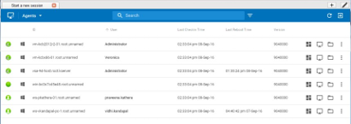

#### Browsing Agents

The **Agent Browser** shows a listing of **Agents** by default. Menu options for the **Agents** list include:

* Asset Summary  Displays the **Asset Summary** page in **Live Connect** for the selected machine..
* Remote Control  Starts a **CloudActiv8 Remote Control** *(page* *i**)* session for the selected machine.
* Files  Displays a file manager for the selected machine.
* 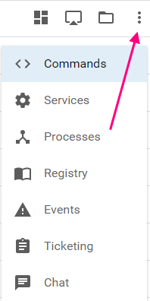You can also click the three dots icon to display additional options.

#### Browsing Assets

The **Asset Browser** can also show a listing of *assets* managed by your CloudActiv8. This includes both agent machines and *non-agent assets*. Non-agent assets can be created when discovering network devices using the **Discovery** module.

To switch to the **Assets** view, use the drop-down filter on the **Agent/Asset Browser** page. To view basic information for a listed asset—agent or non-agent—click the asset info icon  in the row of that asset.

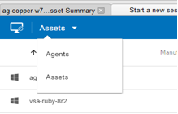

#### Searches

A single search field supports searches for both agents and assets in the **Agent/Asset Browser** window. Entering a string is matched against the following properties:

* agent name
* asset name
* machine group
* agent organization
* currently logged in user
* last logged in user

You can limit search using the following format:

* agent:<searchterm>
* asset:<searchterm>
* groupname:<searchterm>
* orgname:<searchterm>

You can also use the filter  icon to select an agent view definition filter.

# Manage Servers

You can also display the **Agent/Asset Browser** window without logging into the CloudActiv8 by running the **Live Connect** application from your local machine.

* A **Manage Servers** app displays. The **Manage Servers** app maintains the list of CloudActiv8s you have CloudActiv8 admin access to.

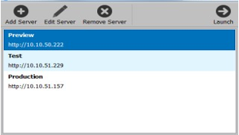

* Click any CloudActiv8 you've added to the list. A login window displays.
* Enter your CloudActiv8 admin credentials for that CloudActiv8.

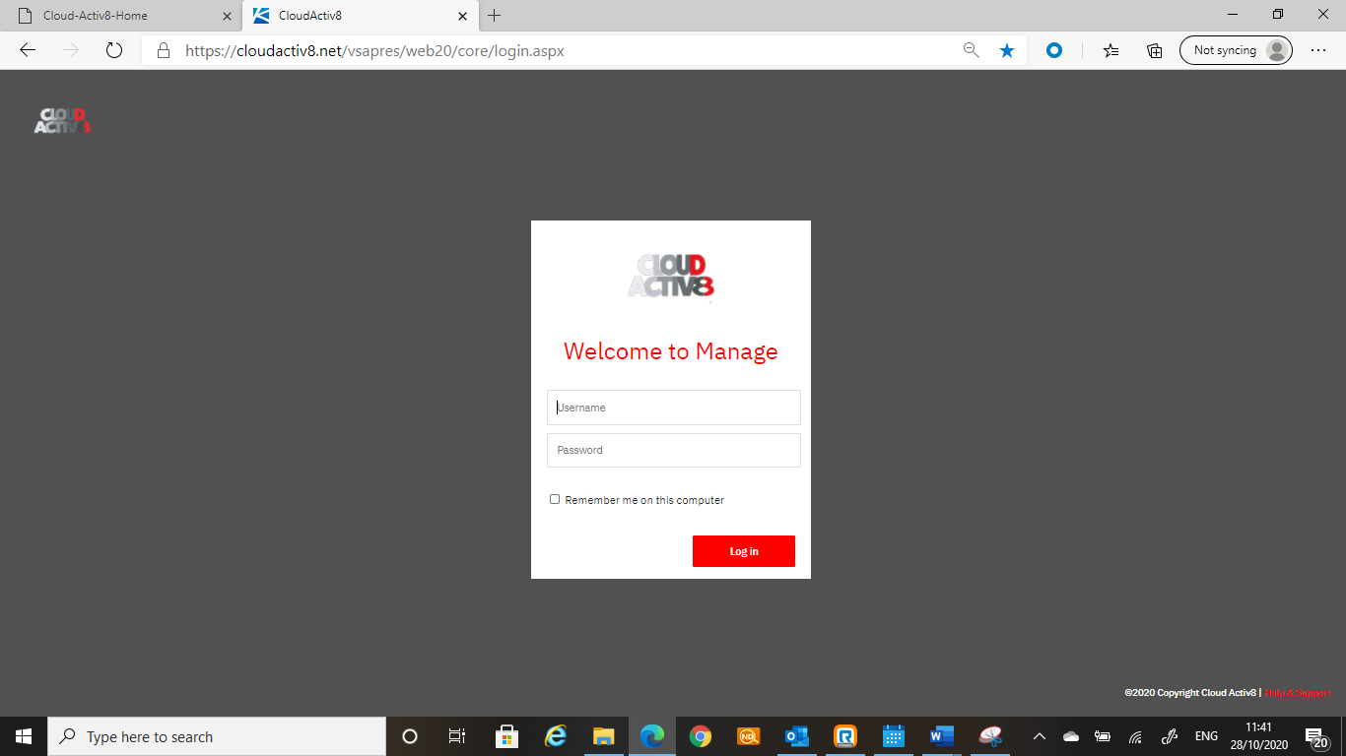

The **Agent/Asset Browser** ('Start a new session') windows displays.

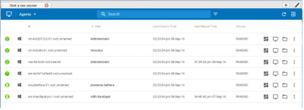

# Live Connect on Demand

**Live Connect on Demand** installs temporary agents on machines. Temporary agents allows **Live Connect** to be used temporarily on a machine, up to a maximum of 12 hours.

* **Live Connect on Demand** *requires the target machine have internet access*.
* After the temporary agent session ends, the temporary agent is automatically uninstalled from the machine. As with regular agents uninstalling may take a few minutes to completely remove the temporary agent.

#### Procedure

1. Use the Agent > Live Connect on Demand > Configuration to configure settings that apply to all temporary agent deployments.
2. Start a **Live Connect** session using any agent.
3. Add a new tab to display the **Asset Browser** ('Start a new session') window listing all the machines you are authorized to manage.
4. Click the monitor icon on the far left of the control bar.

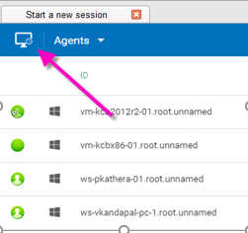

1. In the **Live Connect On Demand** optionally include a **Customer Name** and **Notes**. These display in reports using the Temporary Agent Audit report part.
2. Select one of three methods for sending the download link to the user to install the temporary agent on a machine.
   * **Send Email** - Sends an email to the specified customer email address. The machine user clicks the link in the email message to begin installing the temporary agent. The format of the email message is based on the email template maintained using the Agent > Live Connect on Demand > Configuration page.
   * **Copy to Clipboard** - Copy a link to your clipboard. You can subsequently paste the link in a message sent to the machine user. The machine user clicks the link in the message to begin installing the temporary agent.
   * **Done** - Before clicking this option, provide the machine user with the unique session code displayed with this option. Instruct the user to point their browser to the authentication request service URL. The machine user enters the unique session code you provided on that browser page to begin installing the temporary agent.
3. In the CloudActiv8 look for agent icons adorned with a red clock badge  to identify temporary agents.
4. To select an existing temporary agent to work with in **Live Connect** return to the **Start a new session** tab. **My Agents** lists temporary agents created by the currently logged in CloudActiv8 user. All agents lists all temporary agents your scope allows you to see. For each temporary agent listed you can:
   * **Connect** - Starts a **Live Connect** session with a selected temporary agent.
   * **Cancel** - Uninstalls a temporary agent from its remote machine before the maximum number of minutes allowed expires.

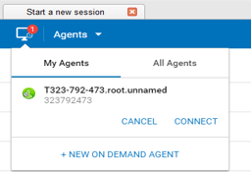

1. Review Live Connect on Demand activities in the following locations:
   * Metrics on the Agent > Live Connect on Demand > Dashboard page.
   * Publish a report that includes the Temporary Agent Audit report part. This includes both installed and uninstalled temporary agents.
   * The creation of Live Connect on Demand install packages are listed on the Agent > Administration > Application Logging page.

# Custom Extensions

**Custom extensions** provide **Live Connect** users with a repository for uploading executables to the CloudActiv8. Stored executables can then be downloaded and executed during a remote-control session using just a single click. This includes 'non-executables' such as MSI installation files and Powershell scripts.

* If a remote-control session is started, the executable runs under the user account associated with that remote-control session.
* If a remote-control session is not started, the executable runs under the system account.
* An executable can also be "run as administrator". In this case the executable is run as a service account, even if a remote-control session is in progress.

###### Procedure

1. Start a **Live Connect** session using any agent.
2. Add a new tab to display the **Asset Browser** ('Start a new session') window, listing all the machines you are authorized to manage.

Click the "puzzle piece" icon on the far right of the control bar.

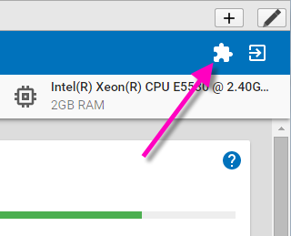

1. **Upload** executables to the repository. After the upload, the executables display in the **Extensions**

list.

1. Optionally **Execute as RC User**. A user must be logged in before this option is clicked to run the executable after it is downloaded to the remote-control machine.
2. Optionally **Download** executables from the repository to your local machine.
3. Optionally **Delete** executables in the repository and remove them from the **Extensions** list.

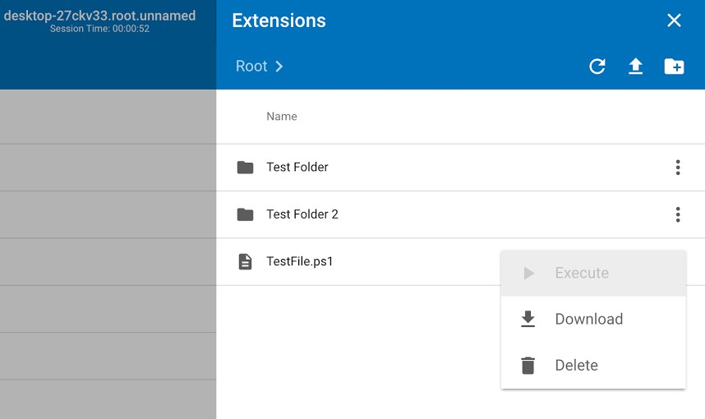

# Live Connect to SSH Assets

**Discovery** automatically determines if certain discovered assets are SSH server enabled. If SSH is enabled, **Live Connect** provides an SSH column on the **Assets** page you click to start an SSH session on that asset. Since you do not have to install an agent, you can use this feature to work with a non-agent device, such as a router or switcher.

###### Prerequisites

* The asset must have SSH server installed on it. The SSH server must:
  + Support tunneling.
  + Require password authentication.

**Procedure**

1. Run a network scan in **Discovery**.
   * SSH server detection is part of every **Discovery** scan. No option has to be set.
   * The SSH target device must be discovered and promoted to an asset during the **Discovery**

scan. An agent does not have to be installed on the SSH target device.

* + At least one Windows device on the same discovered network must have an agent installed on it.

1. Start a **Live Connect** session.
2. Add a new tab to display the **Agent/Asset Browser** ('Start a new session') window.
3. Click **Assets** to display the list of discovered assets you are authorized to see.
4. Click any asset with SSH in bold to start a new SSH session.
5. When prompted, enter the credentials required by the SSH server.

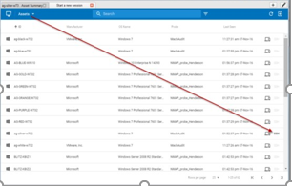

# Live Connect Mobile

**Live Connect Mobile** runs in web browsers—desktop and mobile—with limited **Live Connect** capabilities and does not require any software installation. Use the following URL format to log into Live Connect with your mobile device.

<http://www.yourcompany.com/liveconnect>

Unsupported features in **Live Connect Mobile**:

* Remote control
* Desktop thumbnail
* **Live Connect to SSH assets**
* **Live Connect on Demand**
* Uploading and downloading of files, documents, and **custom extensions**

See **Live Connect** system requirements.

#### Important Caveat

**Live Connect** session timeouts are enforced in the CloudActiv8, with a default of 30 minutes. You are required to log into **Live Connect** any time your previous session has expired.

#### Adding Live Connect to a Mobile Device's Home Screen

The *Home Screen* feature on iOS and Android allows you to achieve an app-like experience for web applications, without the need to install an app, take up valuable device storage, or grant permissions. Once added, the app behaves similar to other installed apps in the following ways:

* Adds a shortcut link to your home screen / apps list.
* Integrates into the OS app switcher mechanisms.
* Provides a full screen experience.
* Is included in the OS app search facilities.
* Can be uninstalled just like a traditional app would.

##### Safari on iOS

1. After navigating to **Live Connect** via Safari on an iOS device, click this icon on the right side of the browser's header bar and select **Add to Home Screen**.

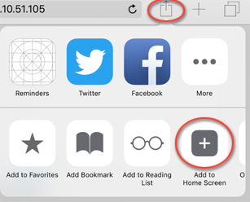

1. Click the **Add** button.

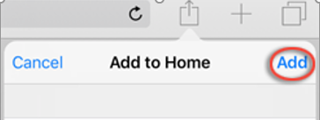

You now have a home screen app for **Live Connect**!

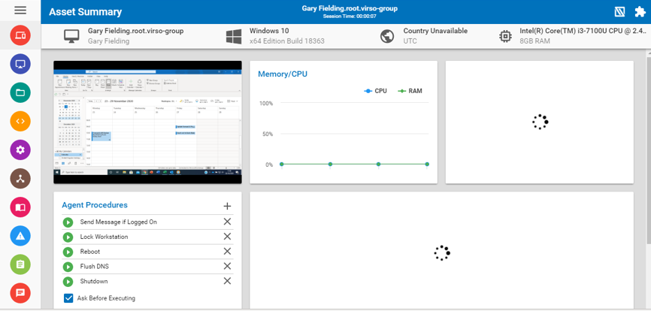

##### Chrome on Android

1. After navigating to **Live Connect** via Chrome on an Android device, click this icon on the right side of the
2. browser's header bar.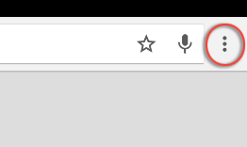
3. Select the **Add to Home screen** option.
4. 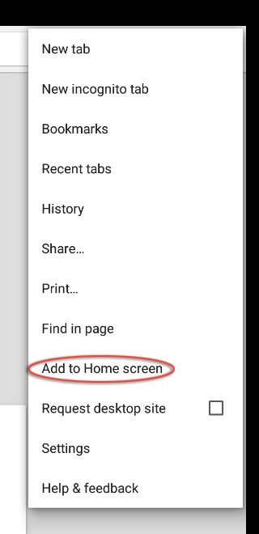Click the **Add** button.

You now have a home screen app for **Live Connect**!

# Live Connect PowerShell

The **Live Connect PowerShell** console enables administrators to run PowerShell commands and scripts on Windows agents. Live Connect PowerShell supports:

* Command line completion using the tab key
* Cycling through the command line history, both forward and reverse, using the tab key and shift+tab key.
* Sending signals (Ctrl+C)
* Copy/paste between external applications and the console, using Ctrl+Insert to copy and Shift+Insert to paste
* Color output support

To select the PowerShell console:

1. Start Live Connect > **Commands ** icon for an agent machine.
2. If not already selected, select **PowerShell** from the drop-down list at the top of the page.

# Live Connect File and Folder Transfers

Files and folders can be uploaded and downloaded between the local machine and remote agent machines using the **Live Connect** interface. This feature is supported on both Windows Mac, for both local and remote machines.

#### Downloading Files and Folders

1. Select the Live Connect > Files  icon for an agent machine.
2. Navigate to the directory on the agent machine you want to download from.
3. Check one or more files or folders.
4. To download a single file or folder:
   * Click the three dots icon *at the right of the selected row,* and click **Download **.
   * Select the download location on your local machine.
5. To download multiple files and folders:
   * Check each file and folder in the current directory you want to download.
   * Click the three dots  icon *at the top of the page* and click **Download** .
   * Select the download location on your local machine.
6. Wait for the **Transfers in Progress** popup window to complete the download.

#### Uploading Files and Folders

1. Select the Live Connect > Files  icon for an agent machine.
2. Navigate to the directory on the agent machine you want to upload to.
3. Select the upload  icon at the top of page.
   * The **Select Files** dialog opens.
4. Navigate in the dialog to the directory on your local machine you want to upload from.
5. Select Files or Directories in the **Files of type** drop-down list.

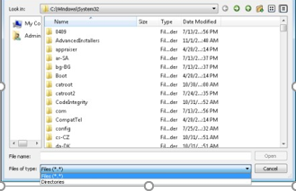

1. Select the files or folders you want to upload.
2. Click **Open**.
3. Wait for the **Transfers in Progress** popup window to complete the upload.

# CloudActiv8 User Portal

A **CloudActiv8 User Portal** version of the new **Live Connect** layout displays when a machine user clicks the agent icon in the system tray. Menu options includes:

###### Home

* **Agent**
* **Tickets**
* 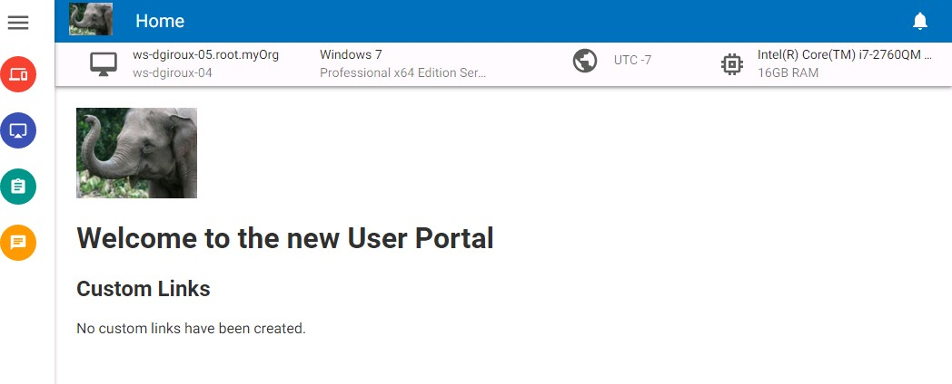**Chat**

**Agent Badges**

Add *badges* to the lower right corner of agent status icons, such as . These badges display everywhere the agent icon displays in the user interface. For example, you could mark a machine with a  badge to indicate the customer requires a phone call before anyone works on that machine. Or mark a server with a  badge because you should not do anything to it until after hours.

Select one or more machines on the Agent > Configure Agents > Edit Profile page, then click the **Icon Badge** link at the top of the page and select one of the available badges. You can define a **Special Instructions** text message for each badge. Click the **Update** button to assign the badge to selected machines.

When you hover the cursor over an agent status icon with a badge, the **Quick View** window displays the

**Special Instructions** text in the bottom of the window.

# Live Connect (Classic)

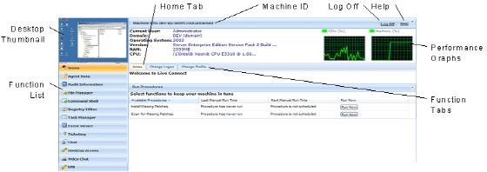**Live Connect** is a web-based, single-machine user interface. You can access **Live Connect** by Ctrl+clicking the agent icon , or by clicking **Live Connect** button in **Quick View. Live Connect** enables you to perform tasks and functions solely for one managed machine. A menu of tabbed property sheets provide access to various categories of information about the managed machine.

Additional menu items display, depending on the add-on modules installed and the operating system of the target machine.

#### Windows

Live Connect for Windows machines supports the following menu items: **Home**, **Agent Data**, **Audit Information**, **File Manager**, **Command Shell**, **Registry Editor**, **Task Manager**, **Event Viewer**, **Ticketing**, **Chat**, **Desktop Access** and **Video Chat**.

#### Apple

**Live Connect** for Macintosh machines supports the following menu items: **Home**, **Agent Data**, **Audit Information**, **File Manager**, **Command Shell**, **Ticketing**, **Chat**, **Desktop Access** and **Video Chat**.

#### Linux

**Live Connect** for Linux machines supports the following menu items: **Home**, **Agent Data**, **Audit Information**, **Ticketing**, **Chat**, and **Video Chat**. Does not include a thumbnail preview image of the desktop in **Live Connect**. Use the Control Machine, FTP and SSH pages to remote control Linux agents.

#### Window Header

Basic information about the managed machine displays at the top of the **Live Connect** window.

* **Thumbnail View** - The desktop of the currently logged on user displays in a thumbnail view, if a user is logged onto the machine.
* **Machine Info** - Lists basic information about the managed machine.
* **Performance Graphs** - Shows CPU % and Memory % performance graphs for the managed machine.
* **Log Off** - Only displays if a machine user using **Portal Access** is logged in remotely from the machine.
* **Help** - Displays online help for **Live Connect**.

#### Menu Options

A menu of tabbed property sheet provides access to various categories of information about the managed machine.

* **Home** - *The* **Home** *tab is the first tab displayed when the* **Live Connect** *window opens*.
  + **Home** - Typically the **Home** tab displays a welcome message and the URL page of the agent service provider. The **Run Procedures** section of the **Home** tab enables the **Live Connect** user to run agent procedures on the managed machine immediately. A **Custom Links** section may display on the **Home** tab, if specified by the service provider, offering links to additional resources. Multiple customized **Home** tabs are possible, each with a unique name, if specified by the service provider.
  + **Change Logon** - Changes the *remote* logon username and password for this managed machine. These logon options enable a user to access the **Live Connect** window to this managed machine from any other machine, including initiating a remote desktop session with the managed machine, if **Desktop Access** is enabled by the service provider. Enter the same URL used to logon to the CloudActiv8. Then enter the **Live Connect** username and password specified in this tab. Accessing **Live Connect** remotely in this manner from another machine is called **Portal Access**. **Portal Access** logon options can also be maintained within the CloudActiv8 using Agent > Portal Access.
  + **Change Profile** - Changes the contact information for this managed machine. This information populates a ticket with contact information when **Live Connect** is used to create a ticket. This information can also be maintained using Agent > Edit Profile.
* **Agent Data** - Displays the following tabs:
  + **Pending Procedures** - Displays and schedules pending agent procedures for a managed machine and the **Procedure History** for that machine. Includes the execution date/time, status and user who scheduled the procedure.
    - Click the **Schedule Another Procedure** button to schedule a procedure not yet pending. Once selected and scheduled, the procedure displays at the bottom of the **Pending Procedures** section.
    - Click the **Schedule** button to schedule a selected procedure to run in the future or on recurring basis.
    - Click the **Run Now** button to run a selected procedure once immediately.
    - Click the **Cancel** button to cancel any selected pending procedure.
  + **Logs** - Displays the logs available for a machine: Alarm Log, Monitor Action Log, Agent Log, Configuration Changes, Network Statistics, Event Log, Agent Procedure Log, Remote Control Log, Log Monitoring.
  + **Patch Status** - Displays Missing and Pending Microsoft patches and schedules missing patches. If a machine belongs to a patch policy, missing patches may be further identified as Denied (Pending Approval). The user can manually override the denied patch policy by scheduling the patch.
    - Click the **Show History** link to display the history of patches installed on the managed machine.
    - Click the **Schedule** button to schedule the deployment of missing patches.
    - Click the **Scan Now** button to scan for missing patches immediately.
    - Click the **Cancel** button to cancel a selected pending patch.
    - Click the **Set Ignore** button to prevent installing a patch using any of the installation methods. To be installed, the **Set Ignore** checkbox must be cleared.
    - Check the **Hide patches denied by Patch Approval** - If checked, patches denied by Patch Approval are not displayed.
  + **Agent Settings** - Displays information about the agent on the managed machine:

###### Agent version

* + - **Last check-in**
    - **Last reboot**
    - **First time check-in**
    - **Patch Policy Membership** - Defined using Patch Management > Membership: Patch Policy
    - **View Definition Collections** - Defined using the **Only show selected machine IDs** option in View Definitions.
    - **Working Directory** - Can also be defined using Agent > Manage Agents.
    - **Check-In Control** - Can also be defined using Agent > Check-In Control.
    - **Edit Profile** - Can also be defined using Agent > Edit Profile.
  + **Documents** - Lists documents uploaded to the CloudActiv8 Server for a managed machine. You can upload additional documents. Provides the same functionality as Audit > Documents.
  + **Get File** - Accesses files previously uploaded from a managed machine. Click the link underneath a file to display the file or run it. Provides the same functionality as Agent Procedures > getFile().
* **Audit Information** - Information tabs include: **Machine Info**, **Installed Apps**, **System Info**, **Disk Volumes**, **PCI & Disk Hardware**, **Printers**, **Software Licenses**, and **Add/Remove Programs**. Provides audit information based on your Latest Audit. You can perform an an immediate audit using the **Machine Info** tab.
* **File Manager** - Displays two file managers, one for your local machine and one for the managed machine. Using the *upper panes* only you can:
  + Create directories and delete, refresh or rename files or directories using either file manager.
  + *Move* files within the *same* file manager using drag and drop.
  + *Copy* files *between* file managers using drag and drop.
* **Command Shell** - Opens a command shell on the managed machine. Defaults to the

c:\windows\system32 directory

* **Registry Editor** - Displays the registry of the managed machine ID. You can create, rename, refresh or delete keys and values, and set the data for values.
* **Task Manager** - Lists Windows Task Manager data for the managed machine. You can stop or prioritize **Processes**, stop and start **Services**, check typical **Performance** benchmarks for each process, categorized by CPU, disk, network, and memory, review **Users** session data, **Reboot**, power off the managed machine, or log off sessions on the managed machine, and display **User and Groups** on the managed machine. Launching the **Task Manager** lets you create or modify monitor sets using a wizard, based on processes and services. Hovering the cursor over the monitor icon of a log entry displays a wizard.
  + A monitor wizard  icon displays next to each process and service listed on the **Processes** and **Services** tabs of the **Task Manager**. These two wizards enable you to create a new monitor set criteria based on a selected process or service. The new process or service criteria can be added to any new or existing monitor set. The new or changed monitor set is immediately applied to the machine that served as the source of the process or service criteria. Changing an existing monitor set affects all machines assigned to use that monitor set. See Monitor > Monitor Set > Process Status and Monitor > Monitor Set > Services Check a description of each field shown in these two wizards.
* **Event Viewer** - Displays event data stored on the managed machine by event log type.
  + A monitor wizard  icon displays next to event log entries in the CloudActiv8 and in **Live Connect**. Hovering the cursor over the monitor wizard icon of a log entry displays a wizard. The wizard enables you to create a new event set criteria based on that log entry. The new event set criteria can be added to any new or existing event set. The new or changed event set is immediately applied to the machine that served as the source of the log entry. Changing an existing event set affects all machines assigned to use that event set. The monitor wizard icon displays in:
    - Agent > Agent Logs
    - Live Connect > Event Viewer
    - Live Connect > Agent Data > Event Log

See Monitor > Event Log Alerts for a description of each field shown in the wizard.

* **Ticketing** - Displays and creates tickets for the managed machine. Displays and creates tickets for **Ticketing** module tickets or tickets and knowledge base articles for the **Service Desk** module, depending on which module is activated.
* **Chat** - Initiates a chat session with the currently logged on user of the managed machine. You can invite other CloudActiv8 users to join your chat session. See Remote Control > Chat for more information.
* **Remote Control** - Initiates a **CloudActiv8 Remote Control** session with the managed machine.
* **Video Chat** - If a machine user is logged on to a managed machine, then a **Live Connect** user can initiate a audio/video chat session with that logged on machine user. The session can be audio only for one or both machines if video is not supported on one or both machines.
  + **Video Chat with the Machine User** - Click the Call button to initiate the video chat session. The machine user will see a browser window or browser tab display on their machine that lets them see your video image and their own video image if their machine has a webcam installed.
  + **Video Chat with Anyone** - Click the Connect URL button. This copies a URL to your clipboard. Copy the URL address into any email or instant message program and send it to anyone. When that URL is entered in a browser the individual will be able to video chat with you. *Video chat does not require the person receiving the chat invitation to be a managed machine.*
  + **Video Chat Confirmation** - The Adobe Flash Player used to transmit the audio/video stream requires each user click an "Allow" button to proceed with their side of the video chat.
  + **Audio/Video Controls** - Hover the mouse over either video image in the chat window to display audio/video controls.
  + **Text Chat** - You can text chat and video chat at the same time using the same window.
* **VPN** - Windows only. Clicking this option creates a VPN connection between your local machine and the **Live Connect** machine. Once connected, the administrator can connect to other machines sharing the same LAN as the **Live Connect** machine, even if those machines do not have an agent installed on them. This includes using applications such as SSH, or telnet or creating another browser instance that targets these other machines on the same LAN. The VPN session ends when the **Live Connect** window closes or the **Stop VPN** button is selected on the **VPN** menu.
* **Anti-Malware (Classic)** - Displays the **Anti-Malware (Classic)** status of the managed machine, if installed.
* **Antivirus (Classic)** - Displays the **Antivirus (Classic)** status of the managed machine, if installed.
* **Data Backup** - If **Data Backup** is enabled for the managed machine, you can use this menu to:
  + Run backups immediately.
  + Restore selected backups, directories and files, but only to the same machine.
  + Display the status and history of backups.
* **Discovery** - Displays the **Network Discovery** status of the machine, if installed.

#### Plugin Manager

**Live Connect**'s enhanced functionality of the browser is managed by a *plug-in manager*.

* **Plug-in Manager Installation** - The user is prompted to install Plug-in Manager after the first logon. Installation of the Plug-in Manager can be deferred until **Live Connect** is started for the first time.
* **Plug-in Updates** - IE and Firefox browsers will detect plug-ins that are out of date and automatically download them in the background. Browser restart is not required for these two browsers. Chrome and Safari browsers also detect out of date plug-ins and automatically download them in the background, with little to no user interaction required.

#### Additional Notes

* Access to specific **Live Connect** functions depends on access rights in System > User Roles > Access Rights and Machine Roles > Access Rights.
* All of the **Live Connect** menu options are enabled when the machine is connected to **Live Connect**. Only **Home**, **Audit Information, Agent Data** and **Ticketing** are enabled when the machine disconnected from **Live Connect**.
* *You can customize the* **Live Connect Home** *page using System > Customize: Live Connect (page* *xxiv**).*
* **Event Viewer** data does not depend on Agent > Event Log Settings.
* If a externalLink.xml exists in the \Webpages\install directory of the CloudActiv8 Server a **New Ticket** link displays next to the **Help** link in **Live Connect**. Clicking the **New Ticket** link redirects users to the URL specified in externalLink.xml. See **Customized New Ticket Link** for details.

### Setting User Role Access Rights for Live Connect (Classic)

You can configure the functions displayed during a **Live Connect** session to CloudActiv8 *users* using the System

* **User Roles** > Access Rights tab.

#### User Role Access Rights

The **Access Rights** tab in the System > **User Roles** page determines what functions CloudActiv8 users belonging to a selected role can perform. For example, access rights can include whether or not a user can open, add, edit or delete a particular record.

A navigation tree provides access to each module, folder, item, and control in the CloudActiv8.

* + Click the or icons next to any item in the tree to display or hide child branches of that item.
    - A checked item means a role provides access to that item.
    - A unchecked item means a role does *not* have access to that item.
    - Click **Expand All** to expand the entire tree.
    - Click **Collapse All** to collapse the entire tree.
  + Click **Set Role Access Rights** to change access rights for a role.
* Checking or clearing any checkbox sets the same state for any child items.
* Click **Enable All** to enable all items.
* Click **Disable All** to disable all items.

#### Setting User Role Access Rights for Live Connect

A separate **Live Connect** module is listed along with other modules in the **Access Rights** tab tree. You can set different combinations of access rights for each user role and assign them to different populations of CloudActiv8 users.

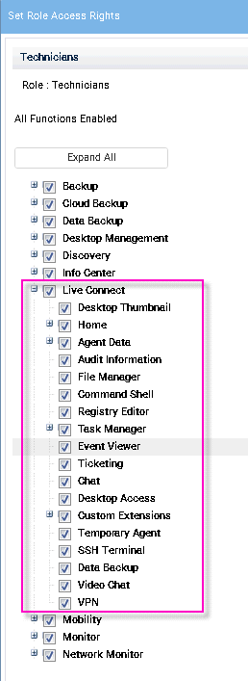

#### Multiple User Role Home Tabs

If more than one **Home** tab is defined using the System > Customize > **Live Connect** page, then both **Home** tabs display in the System > User Roles > **Access Rights** tab tree, underneath the Live Connect > **Home** menu checkbox. For example, you might have two **Home** tabs, one called Home and a second one called Resources. You can enable or disable one or more home pages in the **Access Rights** tree for each user role. This affects the **Home** tabs displayed to the different populations of CloudActiv8 users using these user roles. See Customize: **Live Connect** for more information.

### Customize: Live Connect (Classic)

###### System > Customize > Live Connect

The **Customize: Live Connect (Classic)** page customizes **Home** tabs that display in the **Live Connect (Classic)** and Portal Access (Classic) windows. You can create multiple, customized **Home** tabs and save them by name.

These **Home** tabs are enabled for a particular role by checking the checkbox underneath Live Connect

* + Home in: System > User Roles > Access Rights
  + System > Machine Roles > Access Rights

You can customize three sections on the default **Home** page.

* + **Portal Header** - Customize the text and image displayed at the top of the **Home** tab.
  + **Agent Procedures** - Provide a customized list of agent procedures that the user can run immediately from this tab.
  + **Custom Links** - Provide a customized list of URLs that the user can click using this tab. For example, you could provide a URL to a website page providing technical information used to troubleshoot problems on managed machines.

**Make available to All Tenants**

If checked, this Home page can be added to user roles and machines roles on all tenant partitions. This option only displays for master role users.

### Customized New Ticket Link in Live Connect (Classic)

You can display a customized **New Ticket** link next to the **Help** link on the **Live Connect (Classic)** page. Fill out the externalLink.xml file as described in the comments section of the XML below.

To activate the new ticket link, place the externalLink.xml file in the \WebPages\install\ directory of your CloudActiv8 Server.

<?xml version="1.0" encoding="ISO-8859-1" ?>

<externalLinks>

<!--

URL STRING SUBSTITUTIONS: The URL string displayed is associated

with a particular machine ID. The string is searched for the following case sensitive values and substituted for the values below. machineNameVal - the machine name for the active machine is substituted

in the URL string.

groupNameVal - the group name for the active group.

-->

<ticketLink displayName="Ext Ticket" url="[http://192.168.212.52/?mname=machineNameVal&amp;gname=groupNameVal](http://192.168.212.52/?mname=machineNameVal&amp%3Bgname=groupNameVal)"/>

</externalLinks>

# Quick View (Classic)

Hovering the cursor over a check-in icon displays an agent Quick View window immediately. You can use this window to view agent properties, start a shared or private CloudActiv8 Remote Control session, launch an agent procedure, or launch Live Connect.

Two functions are unique to the Quick View win

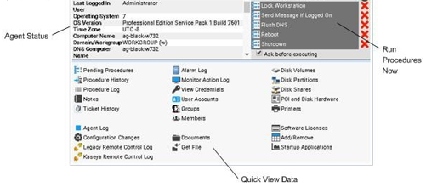

**Screen Shot**

Click the **Screen Shot** button to snap an image of the current desktop. You can access saved images by clicking the **Get File** folder icon in the same **Quick View** window.

#### Private Remote Control

You can use the **Private Remote-Control** button in the **Quick View** window to launch a private session. Private sessions enable administrators to connect to a machine, logon and remote control the machine without accessing the console. An end user working on the same machine at the same time cannot see the administrator's private session.

# Portal Access (Classic)

Portal Access (Classic) is a Live Connect (Classic) session initiated by the machine user.

The machine user displays the **Portal Access** page by clicking the agent icon on the system tray of a managed machine. **Portal Access** contains machine user options such as changing the user's contact information, creating or tracking trouble tickets, chatting with CloudActiv8 users or remote controlling their own machine from another machine. **Portal Access** logons are defined using Agent > Portal Access. The function list the user sees during a **Portal Access** session is determined by the System > Machine Roles page. You can customize **Portal Access** sessions using the System > Customize > **Live Connect** page.

### Setting Machine Role Access Rights for Portal Access (Classic)

#### Machine Roles

The **Machine Roles** page controls access to the **Portal Access (Classic)** window.

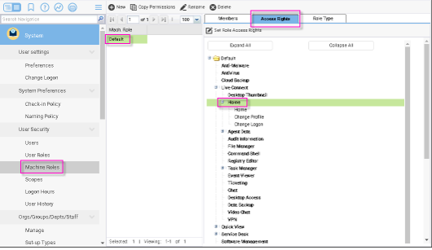

#### The Default Machine Role

A predefined Default machine role is provided when the CloudActiv8 is installed. Newly created machine ID accounts are automatically assigned to the Default machine role when the account is created. If you create other machine roles, you can re-assign machine ID accounts to these other machine roles. You might want to do this if you want to limit machine user access to functions on the **Portal Access** page for different populations of machine users. Each machine ID account can only belong to a single machine role.

#### Machine Role Access Rights

The **Access Rights** tab in the System > **Machine Roles** page determines what functions *machine users* can perform on machines belonging to a selected machine role. For example, access rights can include whether or not a machine user has access to their own machine remotely from another machine.

A navigation tree provides access to each item and control on the **Live Connect** page.

* Click the or icons next to any item in the tree to display or hide child branches of that item.
  + A checked item means a machine role provides access to that item.
  + A unchecked item means a machine role does *not* have access to that item.
  + Click **Expand All** to expand the entire tree.
  + Click **Collapse All** to collapse the entire tree.
* Click **Set Role Access Rights** to change access rights for a machine role.
  + Checking or clearing any checkbox sets the same state for any child items.
  + Click **Enable All** to enable all items.
  + Click **Disable All** to disable all items.

**Setting User Role Access Rights for Live Connect**

A single **Live Connect** module is listed in the **Access Rights** tab tree of System > **Machine Roles**. You can set different combinations of access rights for each machine role and assign them to different populations of machine users.

#### Multiple Machine Role Home Tabs

If more than one **Home** tab is defined using the System > Customize > **Live Connect** page, then both **Home** tabs display in the System > Machine Roles > **Access Rights** tab tree, underneath the Live Connect > **Home** menu checkbox. For example, you might have two **Home** tabs, one called Home and a second one called Resources. You can enable or disable one or more home pages in the **Access Rights** tree for each machine role. This affects the **Home** tabs displayed to the different populations of machine users using these machine roles. See Customize: **Live Connect** for more information.

### Accessing Portal Access (Classic) Remotely

###### Agent > Portal Access

The **Portal Access** page defines the logon name and password, by machine ID, required to use **Live Connect** as a machine user *remotely*. A **Live Connect** session run by a machine user is called **Portal Access**. The functions displayed using **Portal Access** are determined by the System > Machine Role > Access Rights tab.

**Accessing Portal Access Locally**

Machine users do not have to logon to **Portal Access** locally. Clicking the agent icon in the system tray of their machine initiates the **Live Connect** session without having to logon.

#### Accessing the Portal Access Logon Page Remotely

A user can display the **Portal Access** logon page for their own machine from another machine as follows:

1. Browse to the http://your_KServer_address/access/ page, substituting the appropriate target KServer name for your_KServer_address in the URL text.
2. Logon by entering the username and password assigned to machine user's machine ID. This username and password is specified using the Agent > **Portal Access** page in the CloudActiv8.

The **Portal Access** page displays. The machine user can click any menu option as though he or she were logged in from their own managed machine. The user can click the **Desktop** or **File Transfer** menu options to initiate a remote connection to their own machine, create or view ticket, or initiate a chat, if these options are enabled.

A **Log Off** link displays only for machine users accessing **Portal Access** remotely from their machine.

### Enabling Ticketing for Portal Access (Classic) Users on Unsupported Browsers

**Live Connect (Classic)** and **Portal Access** are not supported on certain browsers, such as browsers older than IE8 or Firefox 3.5. Machine users required to work with unsupported browsers can be enabled to create and view Ticketing tickets as follows:

1. Create a separate machine role for unsupported browser users in System > Machine Roles. For example, create a Tickets Only machine role.
2. For the new machine role you just created, uncheck the **Live Connect** checkbox in the System > Machine Roles > Access Rights tab.
3. Assign machines with unsupported browsers to this new machine role.
4. When machine users click their agent icon, a single **Ticketing** window displays instead of the **Portal Access** window.